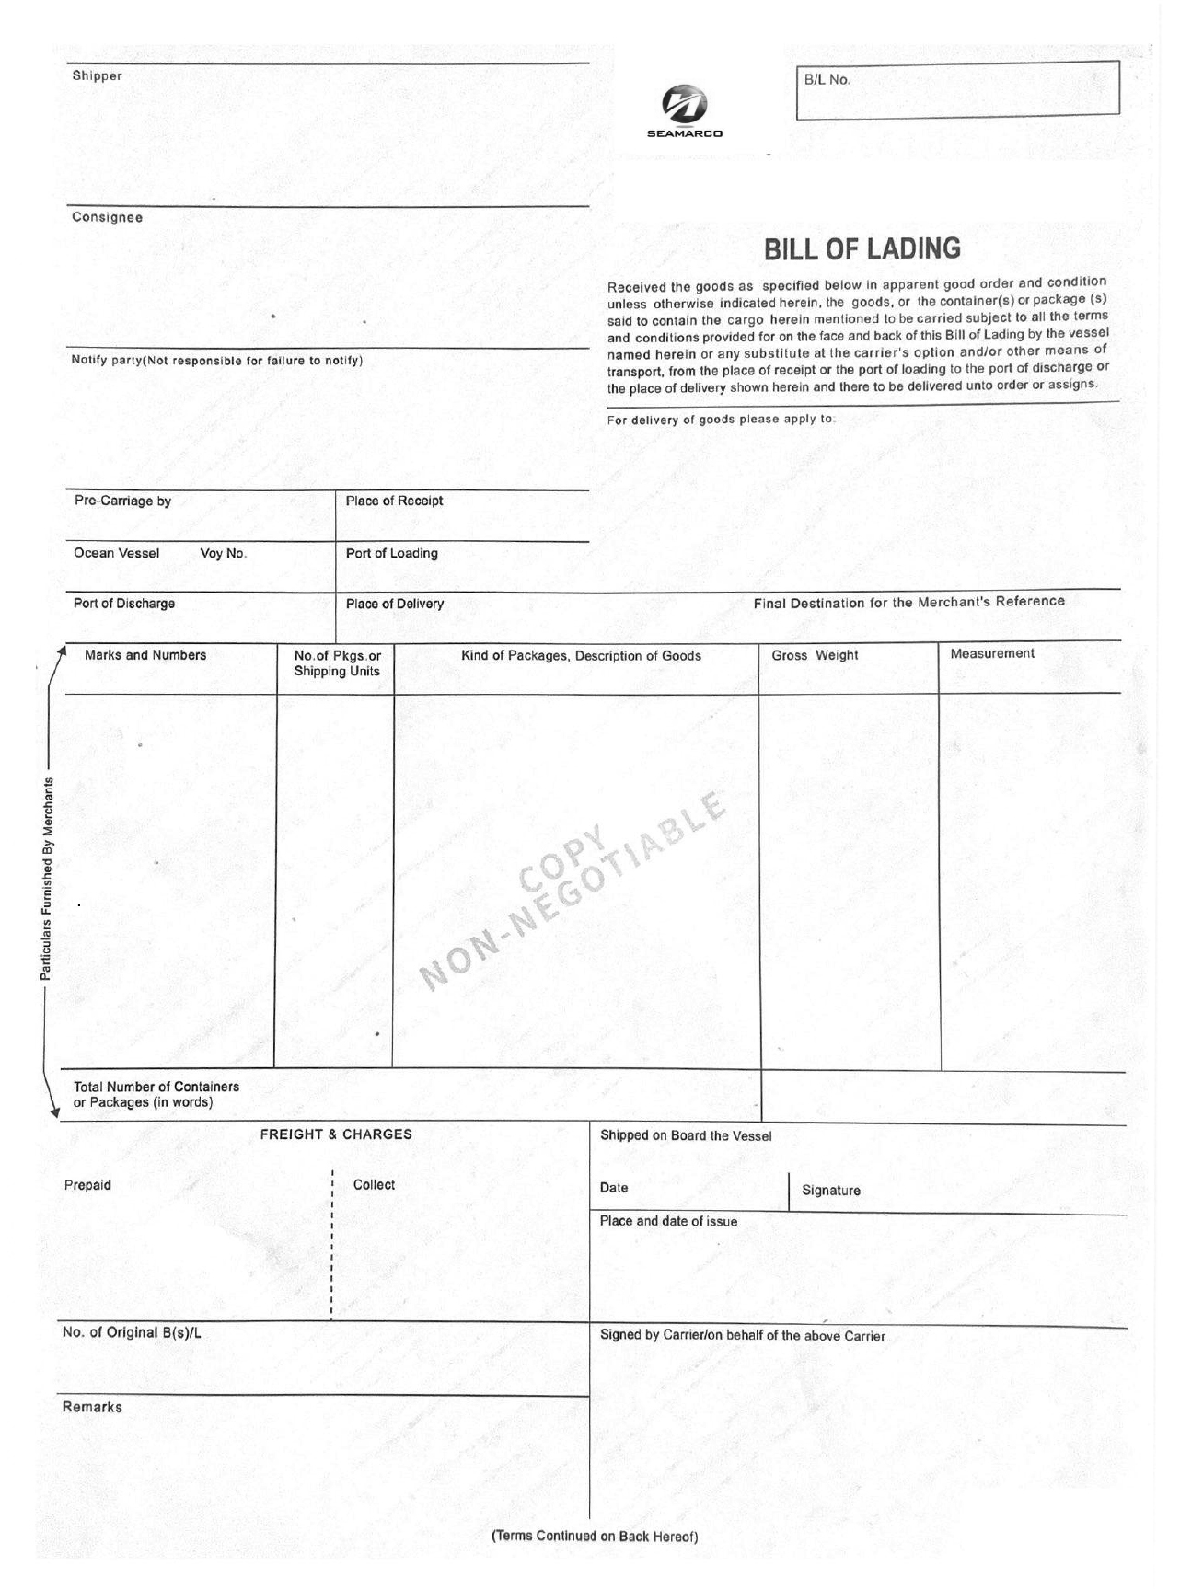
SUZHOU SUDELAN RAILWAY PARTS CO.,LTD.
NO.112 XINJIANG RD,FUQIAO TOWN,TAICANG CITY,JIANGSU
PROVINCE,P R CHINA
0086-51253703217
MS.LU
PANDROL WELDING AND EQUIPMENT INDIA PRIVATE LIMITED.
PLOT NO. 12-20, SECTOR-'A; STREET NO. 26, URLA
INDUSTRIAL AREA, RAIPUR , 492003
CHHATTISGARH , STATE CODE :22
STORE.RAIPUR@PANDROL.COM
IEC : 1194003389 GST : 22AAACH6163L1ZM**
SAME AS CONSIGNEE
WAN HAI 521 V.W035
SHANGHAI
KOLKATA
KOLKATA
N/M
**
PAN : AAACH6163L
MAIL ID :
SOUMYARANJAN.MIS
HRA@PANDROL.COM
SCREW SPIKES
HS CODE:73181190
SPRING WASHER
HS CODE:73182100
20272KGS
15.18CBM
CY TO CY 1X20'GP
SHIPPER'S LOAD,COUNT AND SEAL
FREIGHT COLLECT
SAY TWENTY NINE PKGS ONLY.
THREE
29PKGS
MTMU2914940/FSL2358355/20'GP
/29PKGS/20272.0000KGS/15.1800CBM

SHANGHAI

FAST FORWAD LOGISTICS INDIA PVT. LTD
FLAT NO : 1304 , 13TH FLOOR ,
AMBUJA NEOTIA ECOSTATION STREET 9, BP- BLOCK ,
SECTOR V ,
BIDHANAGAR KOLKATA 700091
WEST BENGAL
GST:19AACCF2972P1Z0
PAN:AACCF2972P
EMAIL:SATINDER.D@FASTLOGISTICSCARGO.COM
PHONE: +918976701679
HTHC25093161

ON BOARD
AS AGENT FOR THE CARRIER:
MTT
CONTAINER/SEAL NO.

